**Land Record Management System Using Blockchain**



**Department of Computer Science**

|  |  |
| --- | --- |
| **JAWAD AHMED** | **NIM-BSCS-2019-59** |
| **SHARJEEL AKRAM**  **MIAN MUHAMMAD ZUBAIR** | **NIM-BSCS-2019-60**  **NIM-BSCS-2019-30** |

**2023**

Final year project report submitted in partial fulfillment of requirement for degree of Bachelors of Science in Computer Science

|  |
| --- |
| **Namal Institute,**  **30-KM, Talagang Road, Mianwali, Pakistan.**  [**www.namal.edu.pk**](http://www.namal.edu.pk) |

**DECLARATION**

The project report titled Land Record Management System is submitted in fulfillment of the degree of Bachelors of Science in Computer Science, to the Department of Computer Science at Namal Institute, Mianwali, Pakistan.

It is declared that this is original work done by the team members listed below, under the guidance of our supervisor Mr. Adnan Bashir and Co-supervisors from System Limited. No part of this project and its report is plagiarized from anywhere, and any help taken from previous work is cited properly.

No part of the work reported here is submitted in fulfillment of requirements for any other degree/ qualification in any institute of learning.

**Team Members University ID Signatures**

Jawad Ahmed BSCS-2019-59 

Sharjeel Akram BSCS-2019-60 

Mian Muhammad Zubair BSCS-2019-30 

**Supervisor**

Mr. Adnan Bashir

**Signatures with date**

__________________________

**Table of Contents**

**ACKNOWLEDGMENTS 5**

**Abstract 6**

Chapter 1 7

Introduction 7

Background and motivation: 7

Objectives 7

Chapter 2 9

Literature Review 9

Land record management system: 9

Related work in the field: 10

Chapter 3 12

System Requirements Analysis 12

Functional Requirements: 12

Non-Functional Requirements System: 13

System Architecture and Design 13

Design Process 16

Use Case Diagram: 18

Block Diagram 24

Block Structure 25

Data Flow Diagram: 26

Sequence Diagram 28

Flow Chart 30

Entity Relationship Diagram 32

Chapter 4 35

Implementation 35

Chapter 7 41

Testing and Evaluation 41

Chapter 9 43

Results and Discussion 43

Interfaces 44

Chapter 8 53

Conclusion 53

Chapter 9 54

Future Work 54

References 56

**List of Figures**

1. Use Case Diagram
2. Block Diagram
3. Block Structure Diagram
4. Data Flow Diagram
5. Sequence Diagram
6. Flow Chart
7. Entity Relationship Diagram
8. Software Process Model

# **ACKNOWLEDGMENTS**

We would like to use this opportunity to offer our sincere gratitude and appreciation to everyone who has assisted us in finishing this final year project. So, first, we would like to thank Mr. Adnan Bashir, our project supervisor, for his leadership, encouragement, and support during the project. He gave us insightful advice and feedback that was helpful to the project's success.

We would also like to express our gratitude to System Limited’s co-supervisors for their help and direction during this process. We are motivated to pursue our interests in the subject of land management systems because of their commitment to teaching and research.

# **Abstract**

Systems for managing land records are crucial for maintaining precise and up-to-date records of land ownership, transactions, and other relevant information. However, fraud, mistakes, and corruption are typically present in traditional land record management systems, which has negative social and economic effects. Blockchain technology has become a potential solution to these issues in recent years. In this project, we suggest a blockchain-based system for managing land records that makes use of the immutability and transparency of the blockchain to build a safe, decentralized, and tamper-proof platform. Our technology enables a wide range of parties to interact with the blockchain network and carry out secure and effective land-related transactions, including landowners, buyers, sellers, and government officials. Performance, usability, and security of the system were assessed. It was developed and deployed using Hyperledger fabric, an open source blockchain platform. According to our research, the system has many advantages over traditional land record management systems, including more openness, lower transaction costs, and better data accuracy and integrity.

# Chapter 1

## Introduction

### Background and motivation:

The maintenance of land records is an essential part of every government's infrastructure since land is a limited resource that is necessary for economic development, social stability, and environmental preservation. However, ineffectiveness, corruption, and fraud hamper land record management systems in many countries, which can lead to disagreements, legal issues, and societal discontent. A practical solution to these problems is the use of blockchain technology to keep land records. Blockchain is a distributed ledger technology that enables secure, open, and impenetrable record storage without intermediaries. Blockchain technology can be used to hold land records in a decentralized and transparent manner, making it simpler to track ownership, stop fraud, and resolve disputes. To create a system that is more effective and affordable, blockchain technology is being used in land record administration. Traditional land record administration procedures can be time-consuming and expensive, requiring a lot of intermediaries, such as lawyers, surveyors, and government employees. Many of these intermediaries may be removed by using blockchain technology, which lowers costs and increases efficiency. Another reason for using blockchain in land record management is to increase transparency and lower the possibility of fraud. Land records maintained on a blockchain cannot be changed without leaving a permanent record due to the immutability of blockchain. Due to this, fraudulent behavior, such as land multiple sales, illegal transfers, and fraudulent registrations, is easier to detect and prevent.

### Objectives

The purpose of this final year project is to create a blockchain-based land management system that provides a safe and transparent platform for managing land records, thereby maximizing the blockchain's benefits. The project's particular objectives are:

1. To build and implement a blockchain-based land management system that enables stakeholders to interface with the blockchain network to conduct secure and efficient land-related transactions.
2. Using various tests and simulations, evaluate the system's performance, usability, and safety.
3. To evaluate the proposed blockchain-based land management system to conventional land record management systems and to determine its potential benefits, such as increased transparency, decreased transaction costs, and improved data accuracy and integrity.

**Scope:**

This project involves the comprehensive examination of the design, implementation, and evaluation of a Land Resource Management System (LRMS) that utilizes blockchain technology, specifically Hyperledger Fabric. The proposed system will encompass essential components, including user registration and authentication, the creation and management of land records, transaction handling, permissions, and access procedures, reporting and analytics functionalities, integration with external systems, and solid data privacy and security measures. The project will prioritize its attention on a simulated setting to facilitate testing and evaluation.

# Chapter 2

## Literature Review

### Land record management system:

The literature on land management systems using blockchain is new but growing rapidly. Several studies have explored the potential benefits of using blockchain technology for land management and the challenges that need to be addressed to achieve its full potential.

**Blockchain in Land Record Management System**

The potential of blockchain technology to revolutionize land record management has attracted significant interest. Blockchain technology provides a decentralized and unchangeable ledger system that guarantees the transparency, security, and reliability of transactions. The implementation of smart contracts in land record systems based on blockchain technology enables the automation and simplifying of processes, resulting in a decreased dependence on intermediaries and an overall improvement in efficiency. Using cryptographic techniques in the context of blockchain technology maintains the integrity and confidentiality of data, effectively reducing worries about unauthorized data manipulation and access.

**Research Papers**

1. "Blockchain for Land Administration" by Peter van Oosterom and Jantien Stoter (2018):

The authors explore the potential applications of blockchain technology in the domain of land administration and management. The authors propose that the implementation of blockchain technology can enhance transparency and security within land record management systems. Additionally, they contend the utilization of blockchain can facilitate the development of smart contracts, therefore performing transactions. The authors additionally acknowledge certain challenges, including the necessity for standardization and connectivity.

1. "Blockchain-Based Land Registry: Case Studies and Analyses" by Gabriel Alfonso Otero and José Manuel Sáez López (2019):

The authors conduct an analysis of extant land registry systems that are based on blockchain technology, specifically examining Bitland and Ubiquity, and subsequently compare them against conventional land registry systems. The authors propose that the implementation of blockchain technology has the potential to provide advantages such as enhanced levels of transparency, increased security measures, and enhanced operational effectiveness. Nevertheless, the authors acknowledge that the successful implementation of a land registry system based on blockchain technology necessitates significant financial resources and extensive cooperation among various stakeholders.

1. Another study by Abbasi and Sarker (2019) investigated the use of blockchain technology in developing a decentralized land management system. They found that blockchain technology can provide a more secure and transparent way of managing land records and transactions and can also reduce the risk of fraud and corruption in the system.
2. "Towards Blockchain-based Land Administration: A Review of Current Trends and Future Directions" by Tao Cheng, Jun Li, and Jinlong Wang (2020):

The authors conduct a comprehensive analysis of the current body of research related to land management systems that utilize blockchain technology. In doing so, they identify the primary obstacles and prospects associated with this innovative approach. The authors propose that blockchain technology can offer advantages such as enhanced transparency, heightened security, and improved efficiency. Nevertheless, the authors acknowledge that there are certain challenges that must be confronted, including scalability, interoperability, and data privacy.

### Related work in the field:

Relevant work in blockchain-based land management systems refers to research, studies, and projects relevant to the proposed system.

1. Sweden and Georgia have established blockchain-based land registry systems to increase the efficiency and transparency of land transactions, which are examples of relevant work in the sector.
2. Blockchain-based land title systems in Ghana and Honduras: These countries have developed blockchain-based land title systems to address issues related to land tenures, such as insecure land rights and disputes over land ownership.
3. Initiatives taken by the business industry projects, such the Global Property Ledger and the Blockchain Land Registry project, have been initiated to investigate the application of blockchain in land management.

By examining related research in the field, the suggested blockchain-based land management system can be properly conceived, developed, and evaluated. In addition, it can assist identify best practices, potential obstacles, and gaps in the existing literature, as well as shed light on the technological and regulatory requirements for such systems.

# Chapter 3

## System Requirements Analysis

### Functional Requirements:

Blockchain-based LRMSs need these functions:

1. The system allows the process of user registration and account creation.
2. Users can securely verify their identity to gain access to the system.
3. Users can conduct searches for land records by using Land IDs as the primary criterion.
4. Users possess the capability to access the history of any specific Land with its ID.
5. Users who possess the land can only accept the request to sell land from the buyer.
6. The System allows the secure and transparent recording of ownership and land transfers. The blockchain guarantees the secure recording of transactions, thereby ensuring both immutability and transparency.
7. The processes for initiating and authorizing transactions have been clearly defined and possess solid security measures.
8. The system is responsible for the verification of land titles and the legitimacy of transactions. Digital signatures, hash codes, and other cryptographic techniques can potentially achieve this objective.
9. The implemented system uses role-based access control mechanisms to guarantee that users are restricted to accessing land records and conducting transactions only within the boundaries of their designated permissions.
10. The system offers reporting functionalities that enable the generation of various reports, including summaries of land ownership and transaction history.
11. Encryption methods are used to protect data while it is stationary and being transferred.

### 

### Non-Functional Requirements System:

Blockchain-based Land Record Management Systems must meet numerous non-functional needs to operate efficiently. These prerequisites include:

1. To prevent data theft, tampering, and access, the system has strong security. Blockchain technology makes data tamper-proof and unchangeable.
2. As land records increase, the system handles a lot of transactions. Scalability is essential for blockchain technology.
3. System uptime should be 100%. It should also keep current records and avoid duplication and data loss.
4. Fast transaction processing and real-time record updating require a high-performance system. Blockchain technology is tuned for transactional load and high-speed processing.
5. To ensure data integration and interchange, the system interacts with land registry officers.
6. The system is user-friendly for landowners, Government officials and investors. The blockchain technology includes an easy-to-use interface to record and access land records.
7. To adapt to modern technologies and regulations, the system is easy to maintain and upgrade. Upgrading and maintaining blockchain technology requires flexibility.
8. The system is well-documented, including user manuals and technical documentation.

## System Architecture and Design

System architecture refers to the system's overall structure and design. This will cover the system's hardware and software, as well as its numerous modules and levels.

**Software Architecture:**

The software architecture includes the division and arrangement of the software components within the LRMS, establishing its structure and organization. The process involves the choice of operating systems, programming languages, frameworks, and databases. The architectural design should be formulated in a manner that optimally facilitates the fulfillment of the functional requirements of the LRMS. The adoption of a modular and layered approach is frequently employed to enhance the maintainability, reusability, and scalability of a system. Furthermore, when contemplating the utilization of Hyperledger Fabric, it is imperative to integrate the essential elements for the management of records based on blockchain technology within the system architecture.

1. The Hyperledger Fabric blockchain network is utilized as the foundational framework for the LRMS. This technology facilitates the establishment of a private and permissioned blockchain network that effectively preserves an immutable ledger of land records. The network consists of many peers that validate and endorse transactions, thereby ensuring consensus and immutability.
2. Peers refer to network nodes present in the Hyperledger Fabric network, responsible for both maintaining a copy of the distributed ledger and executing smart contracts, also referred to as chaincode. The validation of transactions, consensus formation, and the maintenance of a synchronized state of the ledger are carried out by peers. They actively engage in the endorsement procedure and make significant contributions to the system's overall resilience and decentralization.
3. The chaincode implemented in Hyperledger Fabric serves as the smart contracts that govern the business logic of the LRMS. The system delineates the regulations and procedures governing the administration of land records, encompassing the establishment of fresh records, the modification of preexisting ones, and the facilitation of transactions such as transfers and sales. Chaincode guarantees both consistency and security by executing on every peer and preserving a comprehensive record of all modifications made to the ledger.
4. The MSP component is responsible for managing the authentication and authorization processes of participants within the LRMS network. The system effectively oversees the management of identities and access control policies, ensuring that only individuals with proper authorization can engage with the system. The Managed Service Provider (MSP) guarantees the confidentiality and integrity of land records through the implementation of precise access controls determined by designated roles and permissions.
5. The Ordering Service assumes responsibility for implementing the consensus protocol within the Hyperledger Fabric framework. The system receives validated transactions from other participants, arranges them in a specific order, and consolidates them into blocks, thereby guaranteeing a uniform and unchangeable sequence of transactions throughout the network. The Ordering Service ensures the integrity and immutability of the ledger, thereby preventing any form of tampering or unauthorized alterations.

**Hardware Architecture:**

The LRMS includes the hardware architecture, which comprises the necessary physical infrastructure to facilitate its operational functions. This process involves the careful selection of appropriate servers, storage devices, networking equipment, and other hardware components. When designing architecture, it is important to consider numerous factors including scalability, performance, and fault tolerance. To ensure optimal availability and minimize the potential for data loss, it is essential to implement redundancy measures, such as the integration of backup systems and backup mechanisms.

**Minimum Hardware Requirements:**

The hardware specifications necessary for working the Land Record Management System (LRMS) utilizing Blockchain Hyperledger Fabric when combined with Node.js, Express.js, and Docker will be dependent upon numerous factors, including the projected workload, user volume, and system magnitude. The following are the minimum hardware recommendations:

1. To efficiently handle the computational demands of running the LRMS and processing blockchain transactions, it is advisable to utilize a contemporary multi-core processor, such as the Intel Core i5 or an equivalent model.
2. It is advisable to have at least 8GB of RAM to guarantee optimal performance. However, in the case of larger deployments or the need to handle a substantial number of concurrent users, it is recommended to have a minimum of 16GB or a higher capacity of RAM.
3. Adequate storage capacity is necessary to accommodate the LRMS application code, databases, and related files. It is advisable to have a minimum of 50GB of storage capacity, although the specific storage needs may differ based on the magnitude of the land records and the projected transaction volume.
4. To establish a connection with the Hyperledger Fabric network and enable users to access the LRMS, it is imperative to have a reliable and consistent internet connection. It is advisable to utilize a broadband connection that offers satisfactory upload and download speeds.
5. The LRMS can be implemented on a range of operating systems, such as Windows, Linux, and macOS. Select the operating system that exhibits the highest level of compatibility with the development environment and aligns with individual preferences.

**Modules and Levels:**

The LRMS is composed of multiple modules and levels, each fulfilling a distinct function while participating in mutual interactions to accomplish the system's objectives. The modules include various functionalities such as user interfaces, authentication and authorization mechanisms, record management capabilities, transaction processing functionalities, reporting functionalities, and integration capabilities with external systems. The architectural design should unambiguously establish the demarcations, duties, and interconnections of every module to guarantee a coherent and meticulously organized system.

**Scalability:**

The LRMS comprises multiple modules and levels, each fulfilling a different role while participating in mutual interactions to accomplish the system's objectives. The modules include various functionalities such as user interfaces, authentication and authorization processes, record management capabilities, transaction processing functionalities, reporting functionalities, and integration capabilities with external systems. The architectural design should unambiguously establish the demarcations, duties, and interconnections of every module to guarantee a coherent and meticulously organized system.

## Design Process

1. **Requirements Gathering:**

Gather land record management system requirements initially. Identifying stakeholders, their roles, and the system's functions is required. The requirements should be precise.

1. **System Architecture**:

The system architecture of land record management is clear, secure, and tamper-proof. The architecture should contain the blockchain network, nodes, and smart contracts.

1. **Blockchain Network:**

We have determined the blockchain network Hyperledger Fabric blockchain networks. Scalability, security, and integration should determine the blockchain network.

1. **Nodes:**

The nodes are based on the stakeholders of the land record management system. Each node is responsible for recording the transactions related to their role in the system.

1. **Smart Contracts:**

Smart contracts are developed to automate the business logic of the land record management system.

1. **User Interface:**

The user interface is designed to be simple and user-friendly. The interface will allow nodes to easily interact with the system and perform their tasks.

1. **Testing and Deployment:**

The land record management system will be tested before deployment. The system will be deployed on a test network initially, and then on the production network after it has been tested.

1. **Maintenance and Upgrades:**

The land record management system will be maintained and upgraded regularly to ensure that it continues to function optimally.

## 

## Use Case Diagram:

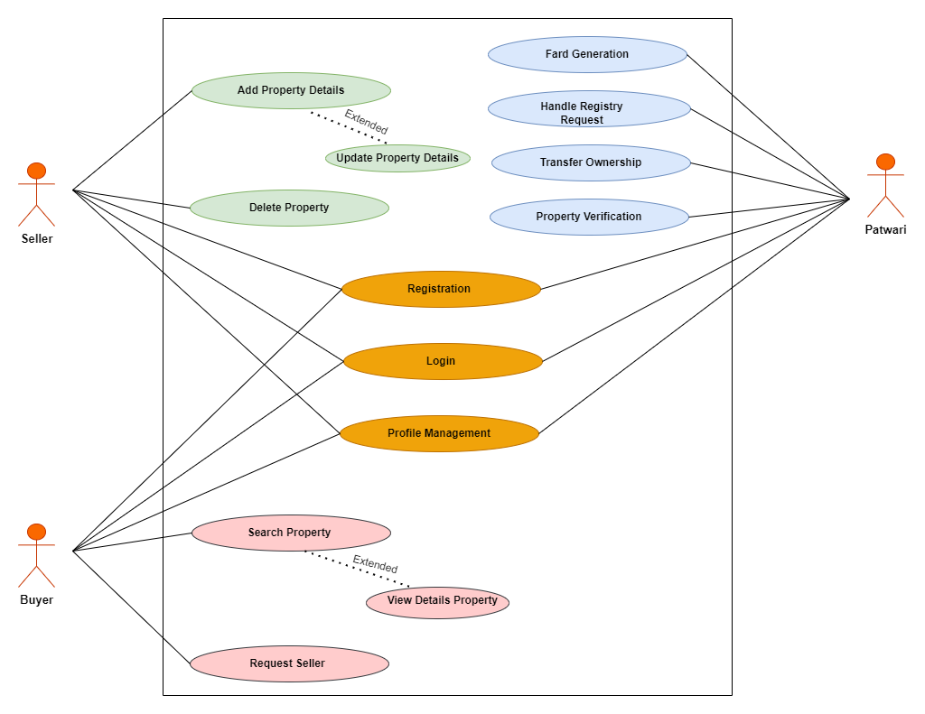

Figure 1:All the use cases of the Land record management system.

**Explained Use cases:**

**1. Use Case Name:**

**User Registration on Land Management System using Blockchain**

**Actor:** User

**Goal:** The user entity wants to create an account on the land management system using blockchain to access the services offered.

**Preconditions:**

1. The user entity has access to the internet.
2. The user entity has navigated to the registration page on the land management system using blockchain.

**Steps:**

1. User information includes name, address, email, and phone number.
2. User accounts have usernames and passwords.
3. User accepts system terms and privacy policy.
4. The blockchain system verifies user identity using their public key.
5. Users will be registered.

**Alternate Scenarios:**

1. User entities will be prompted to correct incorrect email addresses.
2. The user entity will receive an error notice and be prompted to generate a stronger password if their password does not fulfill system criteria.
3. The user entity cannot register unless they agree to the system's terms and conditions and privacy policy.

**System Responses:**

1. The user entity receives a confirmation message after registering.
2. During registration, the user entity will receive an error notice.
3. The user entity's public key will be verified by the blockchain.

**2. Use Case Name:**

**User Login on Land Management System using Blockchain**

**Actor:** User/Login Entity

**Goal:**

The user entity wants to access their account on the land management system using blockchain.

**Preconditions:**

1. User has internet access.
2. Blockchain-registered user entities have land management system accounts.

**Steps:**

1. Blockchain guides the user to the land management system login page.
2. User enters username and password.
3. The blockchain checks the user entity's public key.
4. Blockchain lets users access their land management system accounts.

**Alternate Scenarios:**

1. An error notice will appear if the user entity provides an invalid username or password.
2. User entities cannot access their accounts if the blockchain cannot authenticate their identity.

**System Responses:**

1. The user entity can access their land management system account utilizing blockchain after entering their username and password and being validated.
2. During login, the user entity will receive an error message if wrong credentials are given.

**3. Use Case Name:**

**Add property details for Sale using a Blockchain-based Land Management System.**

**Actor**:

Property Seller, Land Management System, Blockchain Network

**Goal**:

The seller can sell their property via a blockchain-based land management platform.

**Preconditions**:

1. The property seller's online account is verified.
2. The website's land management system employs blockchain technology for safe and transparent transactions.

**Steps**:

1. Sellers describe the property's location, size, and features.
2. The land management system provides a blockchain-stored property token.
3. The digital token contains property ownership history, legal status, and permits or documents.
4. The digital token encodes the property seller's price and terms.
5. The land management system offers the property for sale on the website, where potential buyers can request additional information.
6. Buyers utilize the website to request the property.
7. If the seller accepts, the blockchain network transfers the digital token to the buyer.
8. The land management system changes its property ownership database to reflect the change in ownership.
9. Property sellers and buyers receive digital receipts.

**Alternate Scenarios:**

1. Before listing the property, the seller must create an account and verify their identification.
2. The blockchain network may use a smart contract to resolve property sale or ownership disputes.

**System Responses:**

1. The property seller and buyer receive a digital receipt with complete transaction data, including price, terms, and ownership records.
2. The land management system refreshes its database to reflect property ownership changes.
3. The blockchain network adds a block with transaction details to the blockchain to protect and tamper-proof the transaction.

**4. Use Case Name:**

**Purchasing Property using a Blockchain-based Land Management System**

**Actor**:

Property Buyer, Land Management System, Blockchain Network

**Goal**:

The buyer wants to purchase a property listed for sale on a website using a blockchain-based land management system.

**Preconditions**:

1. The property buyer has an account on the website and has verified their identity.
2. The website's land management system employs blockchain technology for safe and transparent transactions.
3. The website sells a property the buyer wants.

**Steps**:

1. Location, size, characteristics, and price are examined by the buyer.
2. The buyer requests the property via the website.
3. If the seller approves, the land management system creates a blockchain-stored property token.
4. The digital token contains property ownership history, legal status, and permits or documents.
5. The land management system changes its property ownership database to reflect the change in ownership.
6. Property buyers receive digital receipts.

**Alternate Scenarios:**

1. Before buying, the buyer must create a website account and verify their identification.
2. The buyer can submit a new offer or explore the website for other properties if the seller rejects it.

**System Responses:**

1. The property buyer receives a digital receipt with the price, terms, and ownership information.
2. The system refreshes its database to reflect property ownership changes.
3. The blockchain network adds a block with transaction details to the blockchain to protect and tamper-proof the transaction.

**5. Use Case Name:**

**Managing Land Ownership Records using Blockchain Land Management System**

**Actor**:

Patwari, Land Management System, Blockchain Network

**Goal**:

The system user wants to manage the land ownership records using the blockchain-based land management system on the website.

**Preconditions:**

1. The website user is verified.
2. The website's land management system employs blockchain technology for safe and transparent transactions.
3. The land management system accesses blockchain-stored land ownership records.

**Steps**:

1. The user logs onto the website and accesses the land management system.
2. The user uses the system's filters to find a property.
3. The system user sees the property's current owner and transactions.
4. User checks and updates ownership records.
5. The system adds a fresh blockchain block with updated ownership details.
6. The land management system lets users find and settle property ownership problems.
7. The blockchain protects updated ownership records.

**Alternate Scenarios:**

1. While trying to access or edit land ownership records, the system user will receive an error message and must fix it before continuing.

**System Responses:**

1. The system user receives confirmation that land ownership records were changed.
2. The blockchain network adds a new block with updated ownership details to the blockchain, making the transaction safe and tamper-proof.
3. The land management system updates ownership records in its database.

**Implementation Constraints**

1. Land records management can be slowed by blockchain's restricted transaction capacity. So, scaling a blockchain-based land record management system is crucial.
2. Land record management systems may use distinct data formats and protocols, making blockchain integration difficult. Interoperability requires blockchain standards.
3. Blockchain's decentralized, transparent, and immutable ledger makes data privacy difficult. To protect sensitive data, blockchain implementation must address privacy restrictions.
4. A transparent governance framework is needed to implement a blockchain-based land record management system. Clear governance helps resolve conflicts, define user roles and duties, and ensure responsibility.
5. A blockchain-based land record administration system requires blockchain, smart contract, and data management competence. Technical inexperience can delay implementation.

## Block Diagram

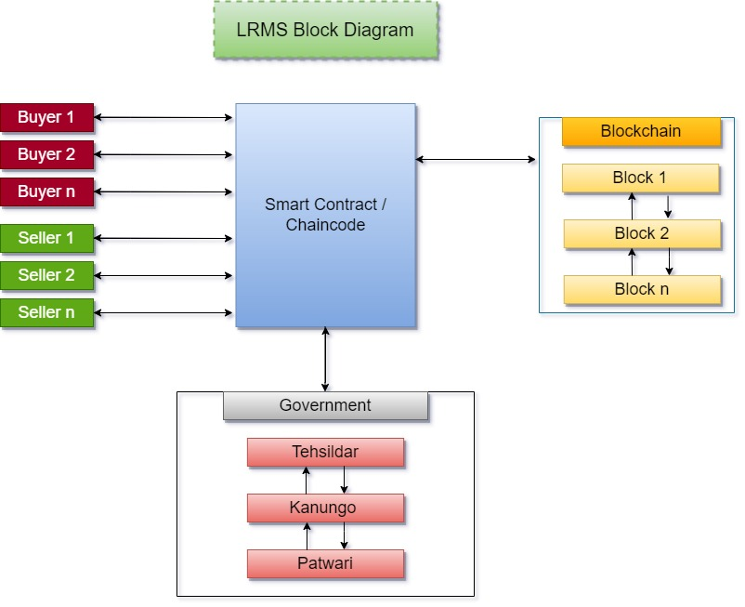

Figure 2: Block Diagram of System that how system interacts with entities.

Here is a brief explanation of the components of block diagram:

1. **User Interface:**

Users interact with the system via the user interface. It lets users access, update, search, and generate reports on land records.

1. **Smart Contracts:**

Blockchain-stored smart contracts run themselves. They automate system business logic like confirming land ownership, updating records, and transferring ownership.

1. **Blockchain Network:**

The blockchain network delivers system security and transparency. A tamper-proof decentralized database records all transactions.

1. **Nodes:**

Blockchain nodes are computers. Each node verifies transactions and stores the blockchain database. In the land record management system, each stakeholder has a node that records their transactions.

## Block Structure

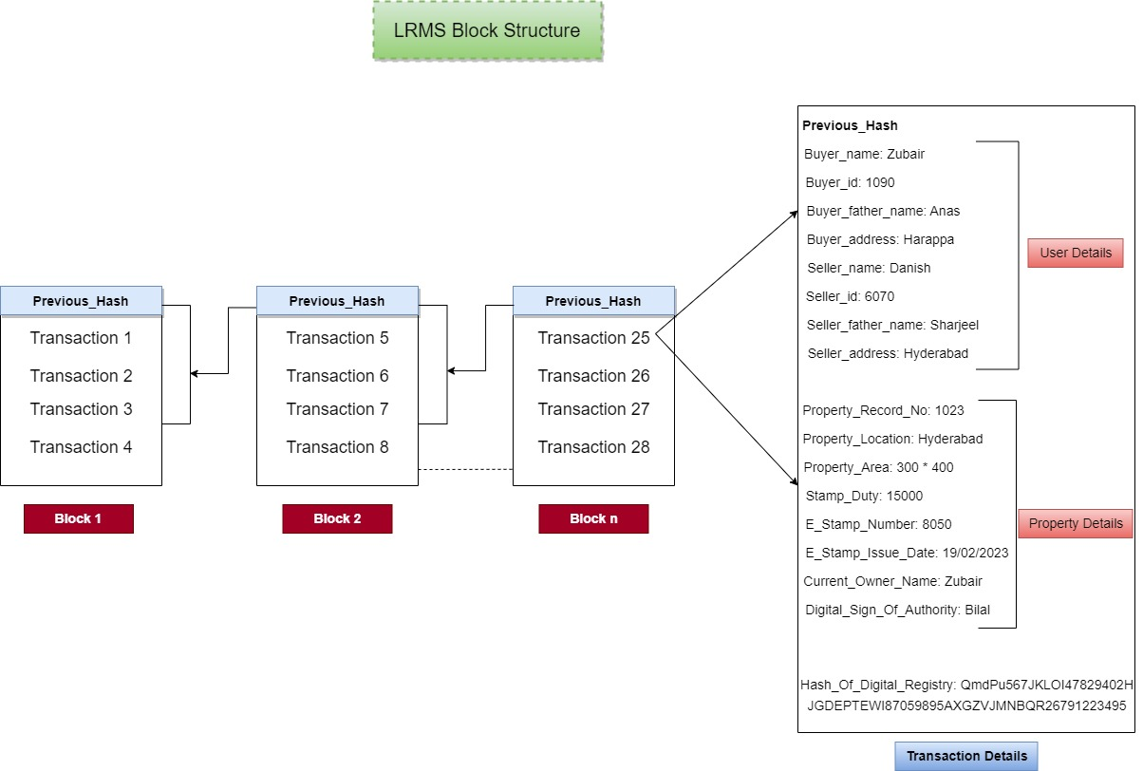

Figure 3: How Block stores the data.

The integrity and security of the system's blockchain are critically dependent on the block's structure in our Land Record Management System (LRMS) project. Every block contains information about land records transactions, including buyer and seller names, buyer IDs, buyer father's name, seller details, address, previous hash, and number. The buyer that participated in the land record transaction is identified by their name and ID in the buyer sections. Similar information about the seller, indicating their position in the transaction, is provided in the Seller Name and ID fields. The land transaction's specifics are kept in the Land Record field, together with pertinent characteristics including the property's dimensions, location, boundaries, and any encumbrances on ownership. The Address field records the location information associated with the land record and adds more context to the transaction.

The Previous Hash field is essential to preserving the continuity and integrity of the blockchain. It establishes a chain of blocks in the blockchain by storing the cryptographic hash value of the previous block's header. The blockchain is made tamper-evident by this linkage, which guarantees that any change to a block's data will result in a change in following blocks' hashes. The value used in the mining process is represented by the Nonce field as a value randomly generated or changes over time. To discover a valid hash that satisfies the requirements of the blockchain's consensus method, miners alter the nonce value. Each block's hash value is made secure and unique with the aid of the nonce.

## Data Flow Diagram:

**Level 0 DFD (Data Flow Diagram)**

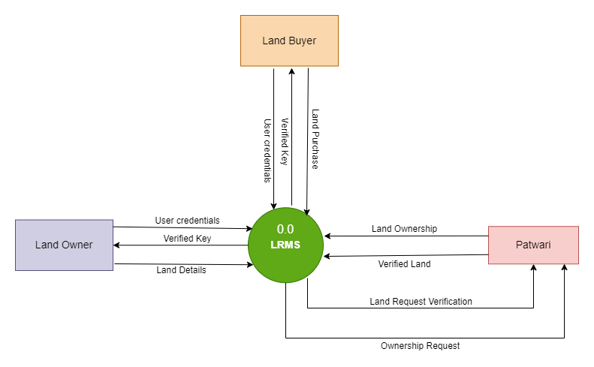

Figure 4: Level 0 DFD or context diagram.

The Level 0 Data Flow Diagram (DFD) for our Land Record Management System (LRMS) project gives an overview of the main procedures and external parties participating in the system. At this level, the LRMS is represented as the system by a single process. The primary process focuses on the input and output data flows and records the interactions between external entities and the LRMS. The Level 0 DFD for our LRMS project lists users including landowners, purchasers, sellers, and government authorities like patwaris as external entities. These entities communicate with the LRMS by sending or receiving inputs and outputs pertaining to land transactions and records. For instance, while buyers and sellers interact with the system to assist land purchases or sales, landowners may initiate land record revisions or transactions. Patwaris oversee validating and confirming the data contained in land records as government representatives.

The data flows between external entities and the LRMS are highlighted in the Level 0 DFD. These data flows describe the transfer of information between the external entities and the LRMS, including information about land record specifics, transaction requests, and verification outcomes. The data flows show the inputs to the system that come from outside sources and the system's outputs produced and delivered back to those outside sources.

**Level 1 DFD (Data Flow Diagram)**

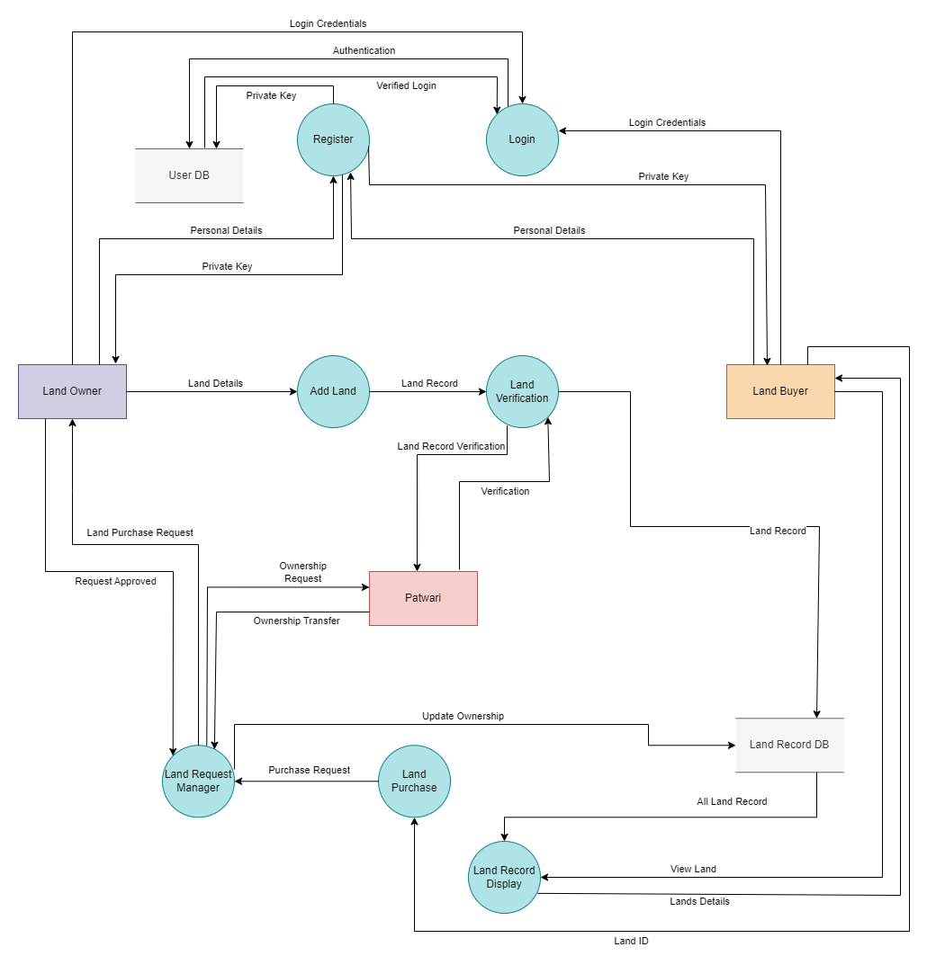

Figure 5: Level 1 DFD of Land Record Management System.

The Level 1 Data Flow Diagram (DFD), in the context of our Land Record Management System (LRMS) project, provides a more in-depth perspective of the system by segmenting the LRMS's primary process into smaller processes. It adds to the Level 0 DFD by illustrating internal LRMS actions and data transformations. The primary subprocesses and how they interact with one another, external entities, and data repositories are the emphasis of the Level 1 DFD. The primary process in the Level 0 DFD is divided into several subprocesses at this level, each of which corresponds to a distinct role or activity within the LRMS. The production of land records, verification, transaction processing, user identification, and data management are a few examples of these subprocesses.

Through the subprocesses, external entities such as landowners, buyers, sellers, and patwaris communicate with the LRMS. They offer inputs that are processed and changed by the LRMS, such as land record information, transaction requests, and user authentication data. The outputs from the subprocesses are sent back to the external organizations as transaction confirmations, land record modifications, and verification findings. Data flows between LRMS sub processes, external entities, and data repositories are highlighted in the Level 1 DFD. It demonstrates the interchange and transformation of data as it passes through the various subprocesses. For instance, information about a land record may pass from the subprocess that creates it to the subprocess that verifies it so that the patwaris can confirm it. For authentication and recording in the data repositories, transaction details may flow through the transaction processing subprocess.

## Sequence Diagram

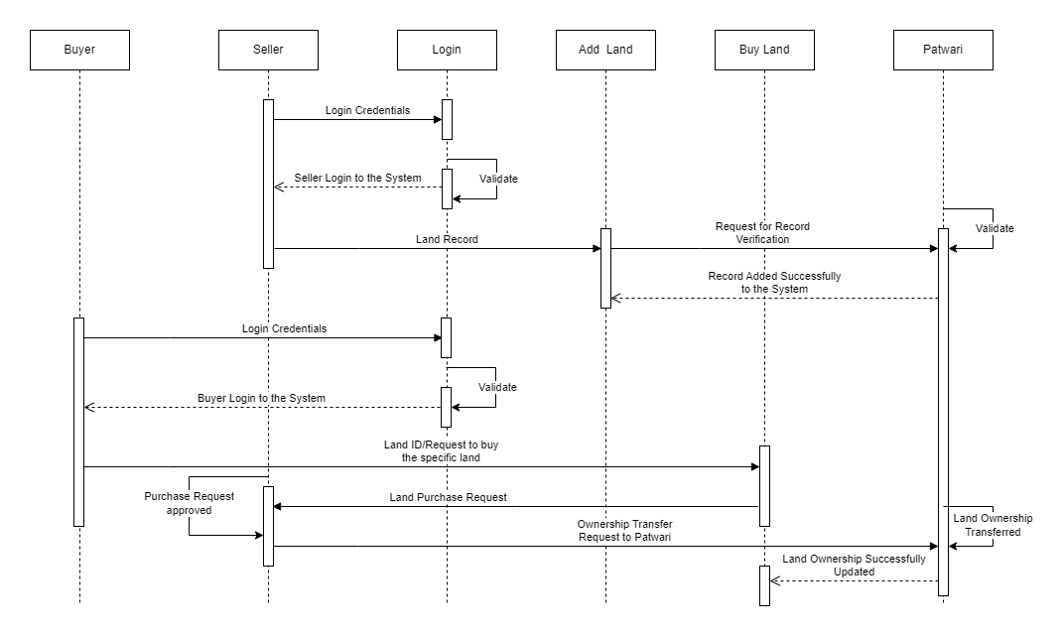

Figure 6: Sequence Diagram of System.

In the LRMS, a user who wants to sell or buy a land record is represented by the Seller or Buyer object. Through system interaction, the Seller starts the land record transaction. The seller is asked by the buyer for the land.

The LRMS's authentication procedure is represented by the Login object. Users must authenticate themselves by providing their credentials whenever they wish to access the system, like the Seller. Upon successful authentication, the Login object verifies the user's credentials and authorizes access to the system.

The procedure of adding a fresh land record to the LRMS is represented by the Add Land object. It entails the Seller giving the required information about the property, including its location, size, survey number, and title deed number. To safely save the land record within the blockchain network, the Add Land object talks with the system.

The process of a user acquiring a land record within the LRMS is represented by the Buy Land object. A land record transaction is started by the Buyer by interacting with the system. The system conducts the ownership transfer from the Seller to the Buyer, confirms the transaction, and changes the ownership information.

Within the LRMS, the Patwari object represents a role or user type. A patwari is typically a government employee in charge of activities involving land. The Patwari object interacts with the system in the sequence diagram, to verify data from land records, amend records, or carry out other administrative duties.

The owner of a land record in the LRMS is represented by the Landowner object. The Landowner may start processes including changing data, monitoring the status of their land records, or starting a land sale.

## Flow Chart

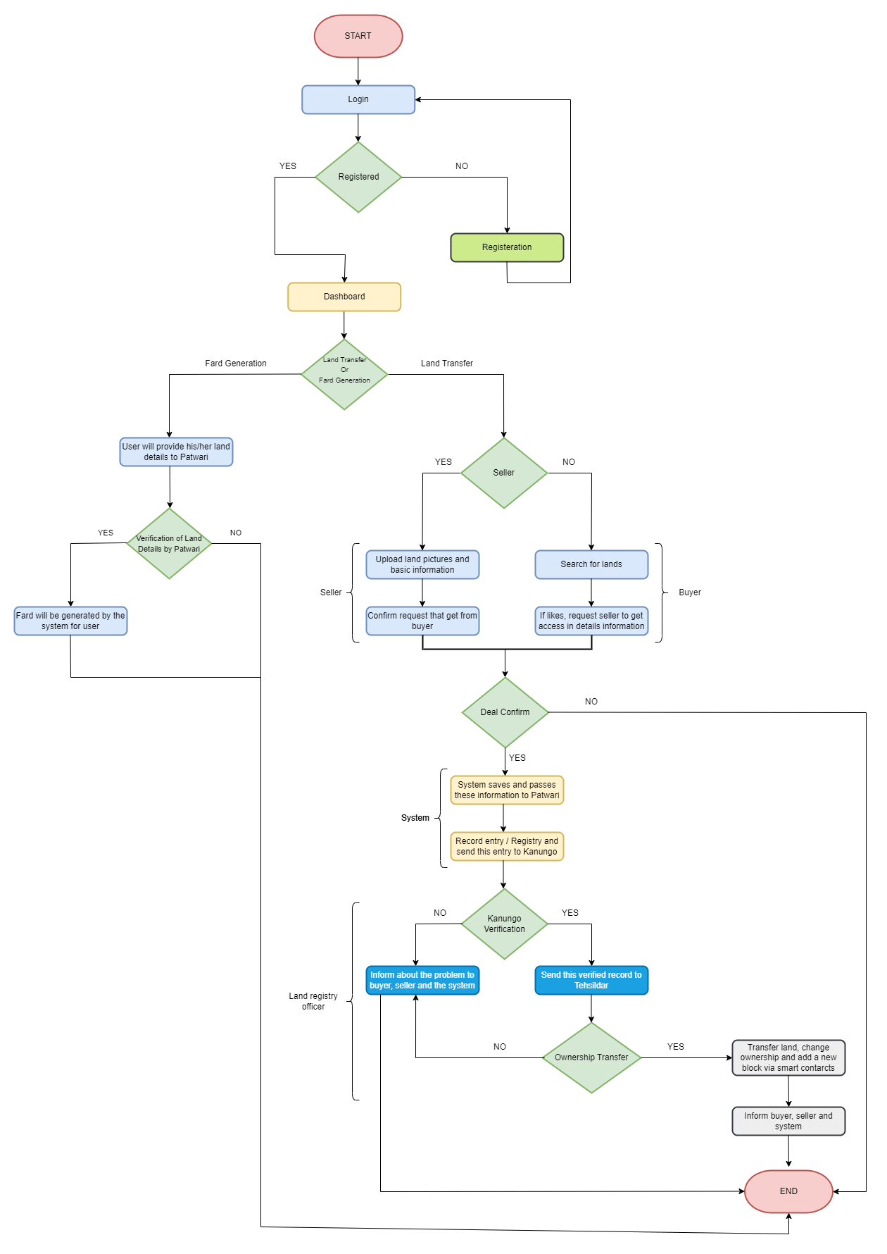

Figure 7: How system actually works in Flow Chart diagram.

A land record management system using blockchain technology involves several steps, as depicted in the following process diagram:

1. The first step is user registration with the system. This involves submitting the necessary user details i.e., Username, Father Name, CNIC, Email Address, Mobile Number, and Password. Once the user is registered, it is assigned a unique certification by the system.
2. Now the user can login using password or private key and after successful login they can choose to generate fard or transfer land functionalities.
3. If the user chooses to generate fard, he will provide land details to Patwari (system node) and the Patwari will verify the documents, if the documents are verified then fard will be generated and if not then it will notify the user for not verifying the documents.
4. If the user chooses to land transfer functionality, then the user again has the option whether he chooses to act like seller or buyer.
5. If the user chooses to be a seller, then he will upload the documents and land information which goes through the chaincode and is finally added into the blockchain.
6. If the user chooses to be a buyer, he will search for land and ask the seller to access the land details.
7. If the deal is done between both parties, then the request goes to the system and passes this information to the patwari, and the entry is made and if the deal is not final then it is ended.
8. If the successful creation of an entry is sent to the Kanungo, then he will verify the registry. If the verification is not successfully made, then the user is informed about the problem.
9. After verification is successful, the record is sent to the Tehsildar, and after checking the revenue officer will write his final comments. And if the revenue officer does not get the proper comment, then the user will inform them about the problem.
10. If the Revenue officer gives successful comments, then the land will be successfully transferred and changed ownership, in this way a new block through chain code will be added to the system.
11. After successful land transfer commits the buyer, seller and system will inform about the transaction.
12. Finally, after a successful transaction the system will be ended.

**Entity Relationship Diagram**

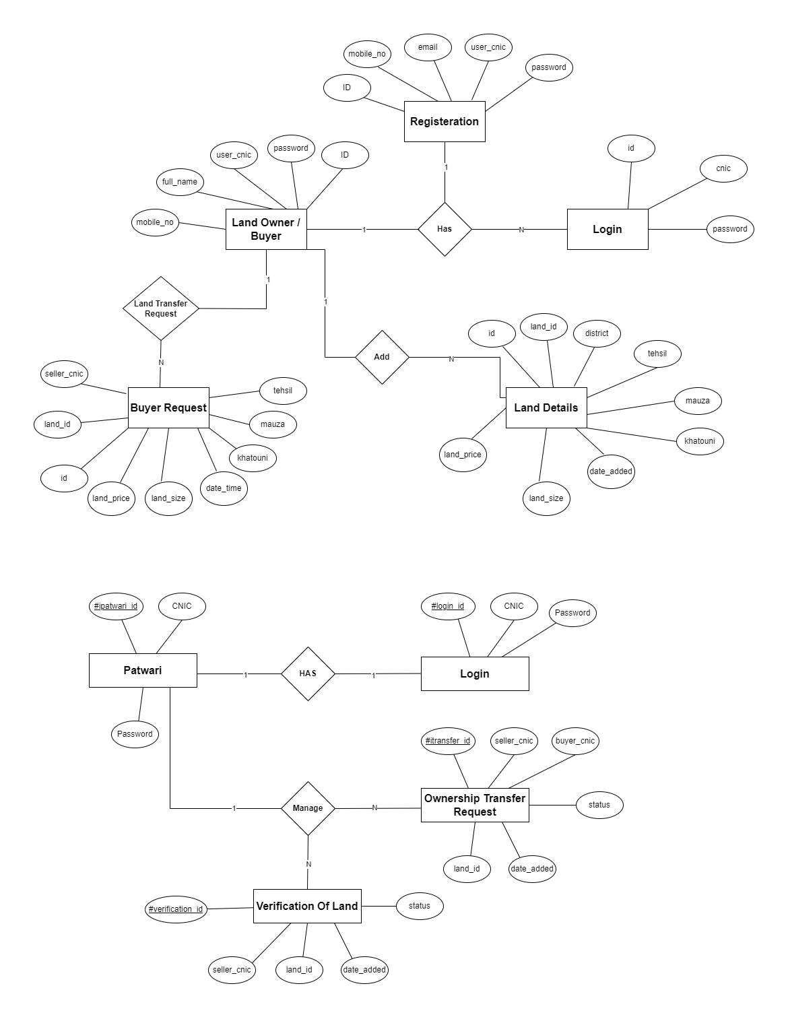

Figure 8: ERD of database of the system

The logical structure and relationships between the entities in the Land Record Management System (LRMS) are shown in the Entity-Relationship Diagram (ERD). It offers a visual representation of the relationships and interactions between various LRMS elements. The ERD acts as a template for comprehending the relationships between distinct data elements in the data model.

The primary components of the LRMS ERD are "Land Record," "User," "Transaction," and "Authentication." The "Land Record" entity, which holds information such the location of the land, its area, its ID, and its title, serves as the system's fundamental unit of information. The "User" entity, which has properties like a username, password, and contact information, stands in for users who communicate with the system. The "Transaction" entity records information on land transactions, including the buyer, seller, date of the transaction, and price. The "Authentication" entity is to confirm user credentials before granting access to the system.

The relationships depicted in the ERD are crucial for understanding the connections between entities. For instance, the association between "User" and "Authentication" shows that each user has an associated authentication record that is used to confirm their identity when logging in. The connection between "User" and "Transaction" suggests that a single user may start or take part in numerous land transactions. The ERD may also include additional relationships like "Ownership" and "Verification" to reflect the ownership history of land records and the procedure for confirming the legitimacy and authenticity of transactions. Through these connections, the LRMS can keep an accurate record of land ownership and transaction history.

Stakeholders may clearly understand the data structure and information flow within the LRMS by displaying the entities and their relationships in the ERD. It supports database implementation, system design, and the creation of software parts that communicate with the database. The ERD acts as a base for data integrity, ensuring that data is precisely gathered, saved, and linked across various LRMS entities.

**Network Architecture Diagram**

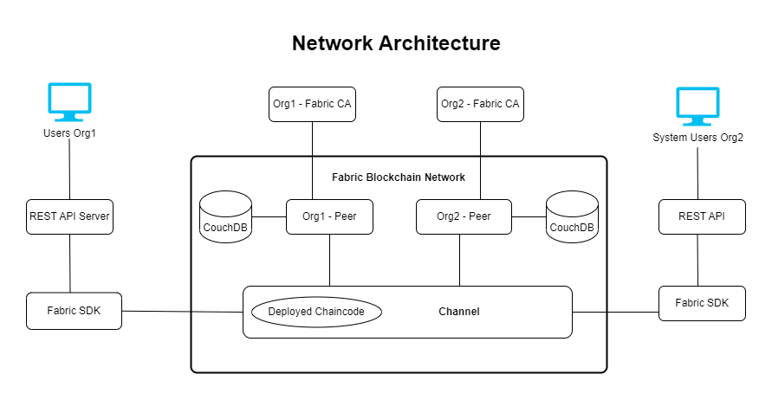

Figure 9: Network Architecture of Blockchain System.

**Software Process Model:**

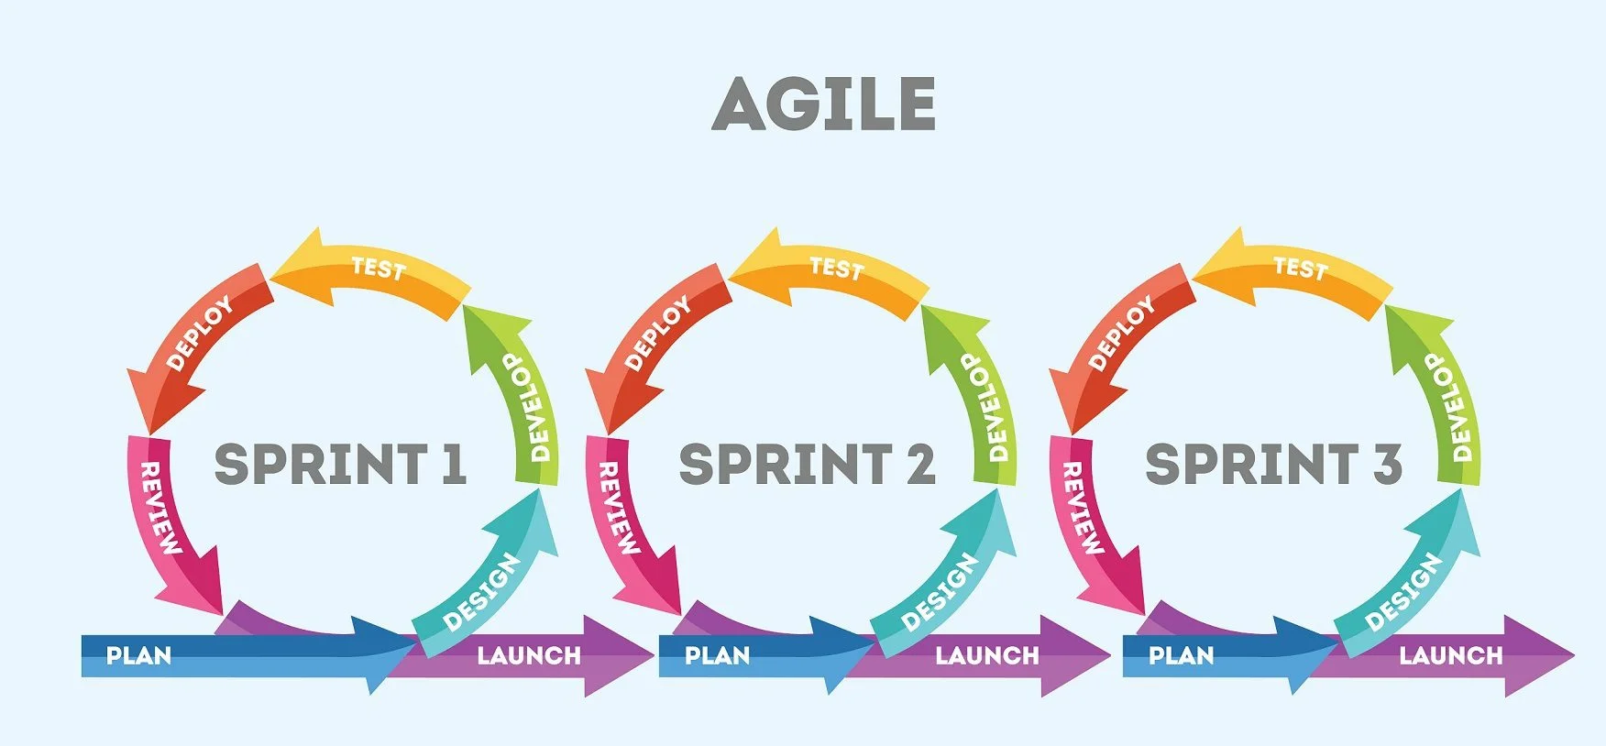

The Land Record Management System (LRMS) was developed using an agile software development process approach. Agile techniques emphasize flexibility, collaboration, and producing usable software in smaller development cycles. They are characterized by iterative and incremental development. To react to changing needs and ensure constant feedback and improvement during the development process, the LRMS project team has used the Agile approach.

# Chapter 4

## Implementation

**Development Environment Setup:**

The implementation phase of the Land Record Management System (LRMS) involves setting up the development environment for the system's development and setting up. The following steps specify the configuration process:

1. Install the Hyperledger Fabric framework on the development machine. The process involves the installation of the requisite dependencies, Docker, and Fabric binaries.
2. The network configuration for the Land Record Management System (LRMS) refers to the arrangement and setup of network components and settings that enable the LRMS to function effectively. The process includes the establishment of channels, defining the boundaries of organizations, and the configuration of the Ordering Service.
3. Configuring the peers involves the configuration and deployment of peer nodes within the network. Implementing a system with multiple peers is essential to achieve fault tolerance and scalability.
4. The next involves the development of smart contracts, also known as chaincode, which serve as the governing mechanism for the business logic of the LRMS. This paper aims to provide a comprehensive overview of the functions and operations involved in the creation and management of land records, along with the handling of transactions.
5. The next involves the design and development of the user interface for the Learning Resource Management System (LRMS). Develop user interfaces and data entry forms for user registration, land record creation, transaction management, and generating reports.

**Smart Contract Development**

The implementation of the LRMS relies heavily on the development of smart contracts, also known as chaincode. The next steps specify the procedure:

1. The chaincode should be structured and categorized into suitable directories and files. The proposed framework involves the establishment of a comprehensive system for the storage and management of land records, user data, and transaction particulars.
2. The implementation of the requisite functions to facilitate the creation, modification, and management of land records is imperative. It is essential to guarantee that the chaincode effectively implements appropriate access controls and follows established business rules.
3. To ensure the accuracy and consistency of land records and transactions, it is necessary to validate user inputs and conduct data integrity checks.
4. The chaincode should be packaged and deployed to the peer nodes within the Hyperledger Fabric network. Confirm the successful implementation of the chaincode.

**Setting up Back-end Server**

1. To ensure optimal performance, it is recommended to install the most recent stable iteration of Node.js on the development machine. They will serve as the runtime environment in which JavaScript code can be executed.
2. To commence a new project directory, it is necessary to initialize it using npm, which stands for Node Package Manager. The process will involve generating a package. Json file to effectively manage the project's dependencies.
3. The Express.js framework and its associated packages can be installed using npm. The web application framework for constructing the LRMS back-end will be provided by Express.js.
4. The project files and directories should be arranged in accordance with the intended structure. This may encompass distinct directories dedicated to routes, controllers, models, and views.
5. The Express.js configuration entails establishing the necessary parameters, including the port assignment, middleware configuration, and route definition for handling HTTP requests.

**User Interface Design and Development**

The user interface (UI) of the Land Record Management System (LRMS) plays a pivotal role in facilitating a simple and user-friendly experience for users. The next steps specify the process of designing and developing a user interface.

1. The process of structuring and prototyping is employed to establish the structure, navigation, and user interactions of the Land record Management System (LRMS) user interface. Ask for constructive criticism and engage in a process of iterative improvement for the designs.
2. The objective is to create a visually appealing and consistent user interface design by utilizing the preliminary designs and prototypes as a foundation. It is imperative to incorporate usability and accessibility principles throughout the design process.
3. The user interface can be implemented by utilizing suitable web development technologies, including HTML, CSS, and JavaScript frameworks. Integrating with the back-end system involves establishing a connection to the Learning Resource Management System (LRMS) to retrieve and present data.
4. Use the Express.js view engine (e.g., EJS, Pug) to render the UI templates dynamically. Define routes and corresponding view rendering logic to display the appropriate views based on user actions.
5. It is imperative to perform comprehensive testing on the user interface to ascertain its functionality, responsiveness, and compatibility across a diverse range of devices and browsers. Implement improvements based on user feedback and the outcomes of testing.

**Integration with Hyperledger Fabric Network**

The process of integrating the LRMS with the Hyperledger Fabric network using Node.js and Express.js encompasses the subsequent stages:

1. Utilize the npm package manager to install the necessary Hyperledger Fabric client packages designed for Node.js. The packages offer the essential resources for engaging with the Hyperledger Fabric network from the backend.
2. Incorporate API (application programming interfaces) routes within the Express.js framework to facilitate the exchange of data between the LRMS backend and the Hyperledger Fabric network. In the context of land record management, endpoints are defined as the specific points where land record creation, transaction handling, and other related operations can be performed.
3. The Hyperledger Fabric client packages should be employed in order to engage with the deployed chaincode. The required functions within the chaincode should be invoked in order to facilitate the creation of land records, execute transactions, and retrieve data.
4. To ensure the security of data during transmission, it is recommended to incorporate robust communication protocols, such as HTTPS, between the back end of the LRMS and the Hyperledger Fabric network. This will effectively safeguard the data from potential threats or unauthorized access.
5. Establishing monitoring mechanisms to track the status and progress of transactions within the LRMS is imperative. To guarantee transaction visibility and accountability, it is crucial to incorporate suitable logging and error handling mechanisms.

**Technologies used in Project**

The Land Record Management System (LRMS) project, which uses the Blockchain Hyperledger Fabric, employs following technologies for both back-end and front-end development:

**Back-end Technologies**

1. **Node.js**

Node.js is a runtime environment for JavaScript that facilitates the execution of JavaScript code on the server-side. The LRMS project utilizes this technology as its back-end framework. Node.js is a software platform that offers an event-driven and non-blocking input/output (I/O) model, rendering it well-suited for the development of applications that require scalability and high performance.

1. **Express.js**

Express.js is a web application framework designed specifically for use with Node.js. The provision of a comprehensive range of functionalities for managing HTTP requests, routing, middleware, and other aspects streamlines the process of web application development. Express.js is utilized in the LRMS project for the development of the back-end server and the creation of API endpoints.

1. **Hyperledger Fabric**

Hyperledger Fabric is a blockchain framework that is open source in nature and serves as the fundamental infrastructure for the creation and development of blockchain applications that are specifically designed to meet the requirements of enterprises. This technology's use is observed in the LRMS project to establish a blockchain network with permissioned access. Additionally, it facilitates the implementation of smart contracts, also known as chaincode, and the management of the distributed ledger.

1. **Docker**

Docker is a containerization technology that enables the packaging of applications and their dependencies into separate containers. Application deployment and management across several systems are facilitated by the consistent and portable environment it offers. Docker is used in the LRMS project to manage and containerize the various parts of the application, ensuring consistency and streamlining deployment.

1. **MySQL**

MySQL is a relational database management system (RDBMS) that is free to use and offers powerful data archiving and retrieval features. It is frequently employed for applications that call for the storing of structured data and SQL querying. MySQL is used as the database system to hold land records and related data in the LRMS project. It offers sophisticated querying operations, ensures effective data management, and assures data integrity.

1. **CouchDB**

A NoSQL database that belongs to the class of document-oriented databases is CouchDB. It allows for scalability and flexibility in the management of unstructured and semi-structured data. Replication, conflict resolution, and offline support are among the features offered by CouchDB, which uses a JSON-based document model.

**Front-end Technologies**

1. **HTML (Hypertext Markup Language)**

HTML, which stands for Hypertext Markup Language, is the widely accepted and utilized markup language employed in the creation of web pages. It serves as the standard means of structuring and presenting the content within these pages.

1. **Cascading Style Sheets (CSS)**

CSS, also known as Cascading Style Sheets, is a programming language specifically designed for defining the aesthetic attributes and visual layout of a webpage.

1. **JavaScript**

JavaScript is a programming language that facilitates the implementation of interactive and dynamic features within web pages. The LRMS project uses this tool for managing client-side interactions, validating user inputs, and facilitating communication with the back-end APIs (application programming interfaces).

1. **Embedded JavaScript (EJS)**

Embedded JavaScript (EJS) is a templating language designed to enable dynamic web page development. It is characterized by its simplicity and lightweight nature. The integration of JavaScript code within HTML templates enables a smooth and uninterrupted process of generating dynamic content, iterating over data, and conditionally rendering elements.

# Chapter 7

## Testing and Evaluation

The Land Record Management System (LRMS) project involved implementing manual testing and evaluation procedures to verify the system's functionality, reliability, and user experience. This includes user interactions, data management, transaction handling, and system performance. The following is a comprehensive outline of the testing and evaluation procedures:

**User Interface Testing**

1. The validation of the usability and simplicity of the LRMS was conducted through user interface testing.
2. The system was engaged by users who directed their attention towards user flows, input validation, and error handling.
3. Data related to feedback and observations were gathered to enhance the user interface design and optimize the user experience.

**Functional Testing**

1. Functional testing is conducted to verify that the Land Record Management System (LRMS) satisfies the established functional criteria.
2. The study employed a series of test cases to validate the functionalities of the system, including the creation of land records, processing of transactions, and authentication of users.
3. The LRMS went through an evaluation process to assess its performance in relation to the expected outcomes. Any alterations or problems that arose were properly recognized, documented, and addressed.

**Data Validation and Integrity Testing**

1. A data validation testing procedure was implemented to determine the precision and consistency of the land record data stored within the Land Record Management System (LRMS).
2. The system's capacity to process both valid and invalid data inputs was verified by testers, who ensured that the data was accurately stored and could be retrieved as anticipated.
3. The accuracy and integrity of land records were ensured through the testing of data consistency checks and validation rules.

**User Acceptance Testing (UAT)**

1. User acceptance testing (UAT) is a process that involves actively involving end-users in the evaluation of the Land Record Management System (LRMS) from their unique perspective.
2. Participants engaged in practical activities and offered their evaluations regarding the system's usability, functionality, and overall level of satisfaction.
3. The process of User Acceptance Testing (UAT) facilitated the collection of valuable insights regarding user expectations, preferences, and areas that require improvement. These insights were instrumental in refining the Land Record Management System (LRMS) through the incorporation of user feedback.

# 

# Chapter 9

## Results and Discussion

The Land Record Management System (LRMS)'s use of blockchain technology has shown encouraging results, highlighting the potential advantages of doing so for land record management. In land records, the system has effectively addressed critical issues such as data integrity, transparency, and security. Several observations and insights have been gained through manual testing and evaluation, which has sparked fruitful debates and future LRMS concerns. The LRMS's deployment has improved land record transaction trust and transparency, which is a major outcome. The system makes sure that all land record transactions are safely stored and transparently accessible to relevant stakeholders by utilizing blockchain's decentralized and immutable nature. By offering a trustworthy source of truth for property ownership and transaction history, this transparency aids in the prevention of fraudulent actions and disputes.

Moreover, the immutability and data integrity of land records inside the LRMS have improved with the introduction of blockchain technology. Within the blockchain network, each land record transaction is stored as a safe and unchangeable block. As a result, a transaction's verification, and addition to the blockchain ensure that it cannot be changed or tampered with thereafter, giving a trustworthy and impenetrable record of ownership and transaction history.

The LRMS has shown increased effectiveness and decreased dependency on intermediaries in the maintenance of land records. The technology streamlines the entire process and minimizes human paperwork by automating several processes in the land transaction process through smart contracts. Land transactions may be carried out more quickly and effectively thanks to smart contracts, which also reduce associated expenses and delays by doing away with the need for intermediaries. While the LRMS implementation using blockchain has demonstrated promising results, there are several restrictions and factors to consider.

One of the difficulties is the blockchain network's scalability, as it can encounter limitations while handling a high amount of land record transactions. To ensure the system can scale as the number of land records and users rises, more study and optimization work is needed. User education and awareness initiatives might be required because of the system's paradigm change in land record administration procedures, which will make it easier for users to accept and successfully use the new system. To address any technical concerns, guarantee system dependability, and deliver a great user experience, continuing support and maintenance will also be essential.

## Interfaces

**Web Interfaces**

1. **Home Page**

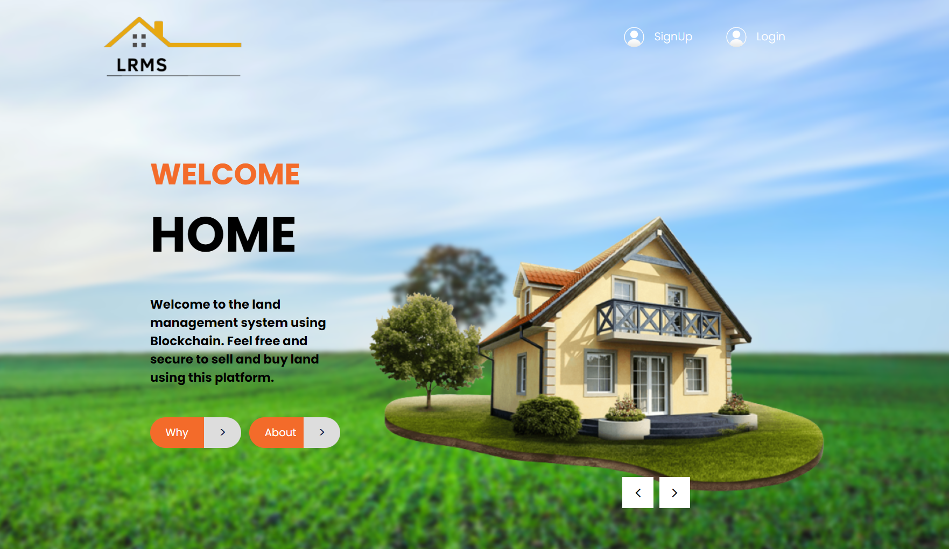

1. **Registration Page**

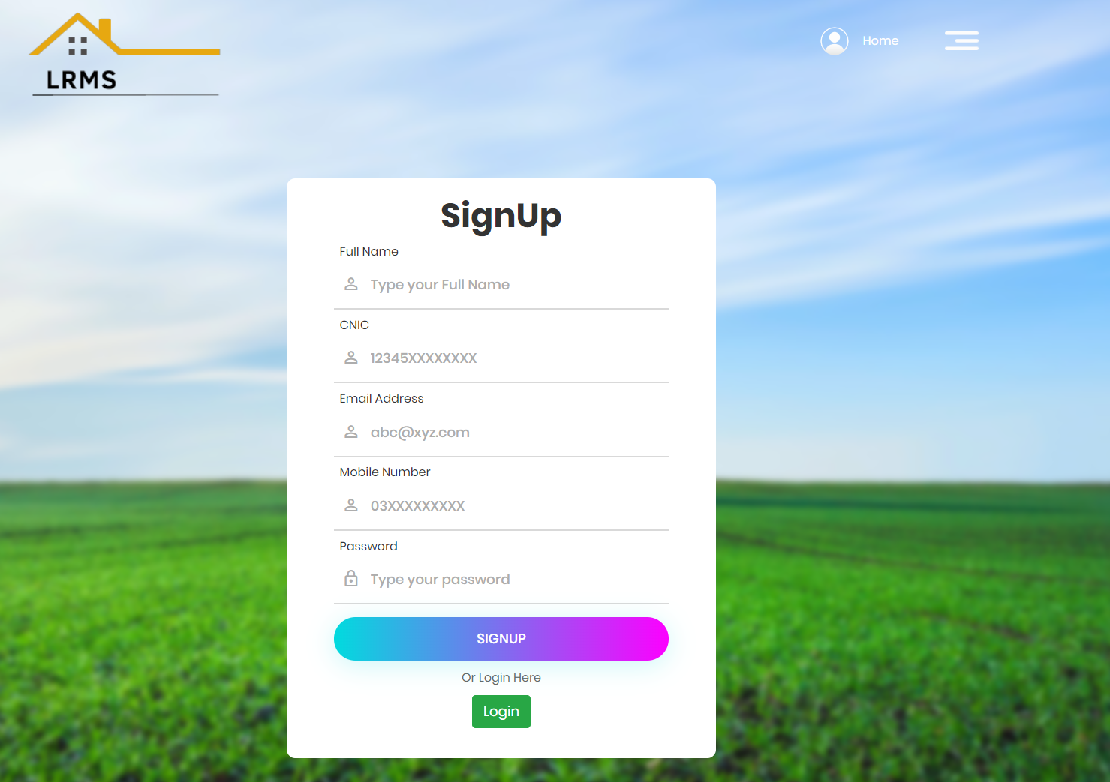

1. **Dashboard**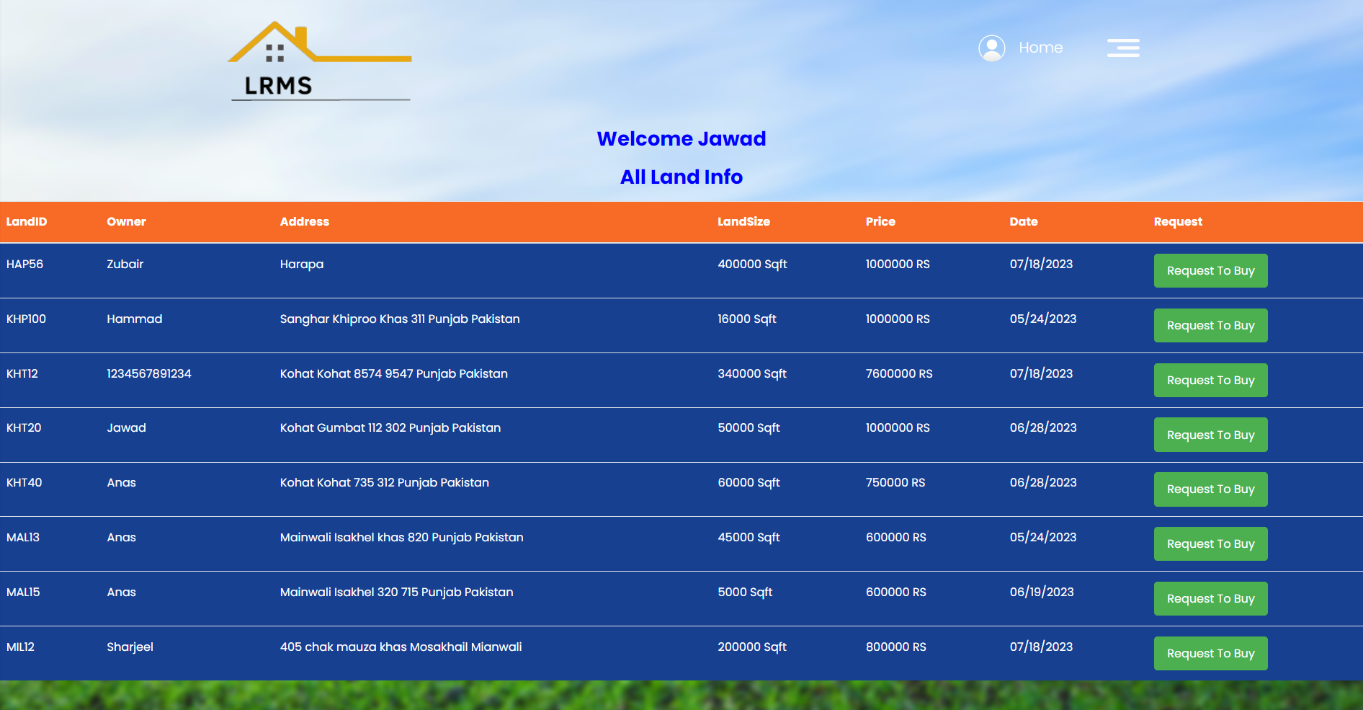
2. **Requested Land Page**

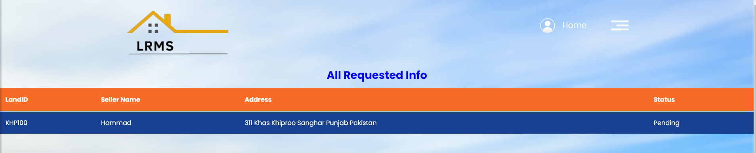

1. **Received Land Record**

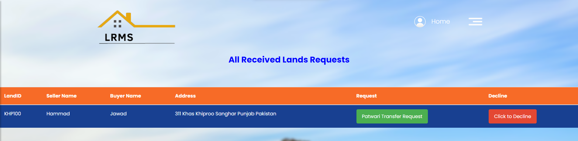

**After Click on the Patwari Transfer Request button**

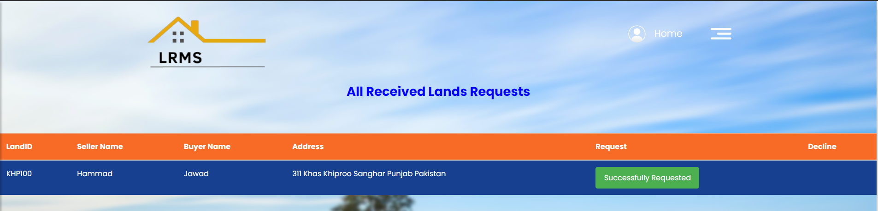

1. **Add Landform**

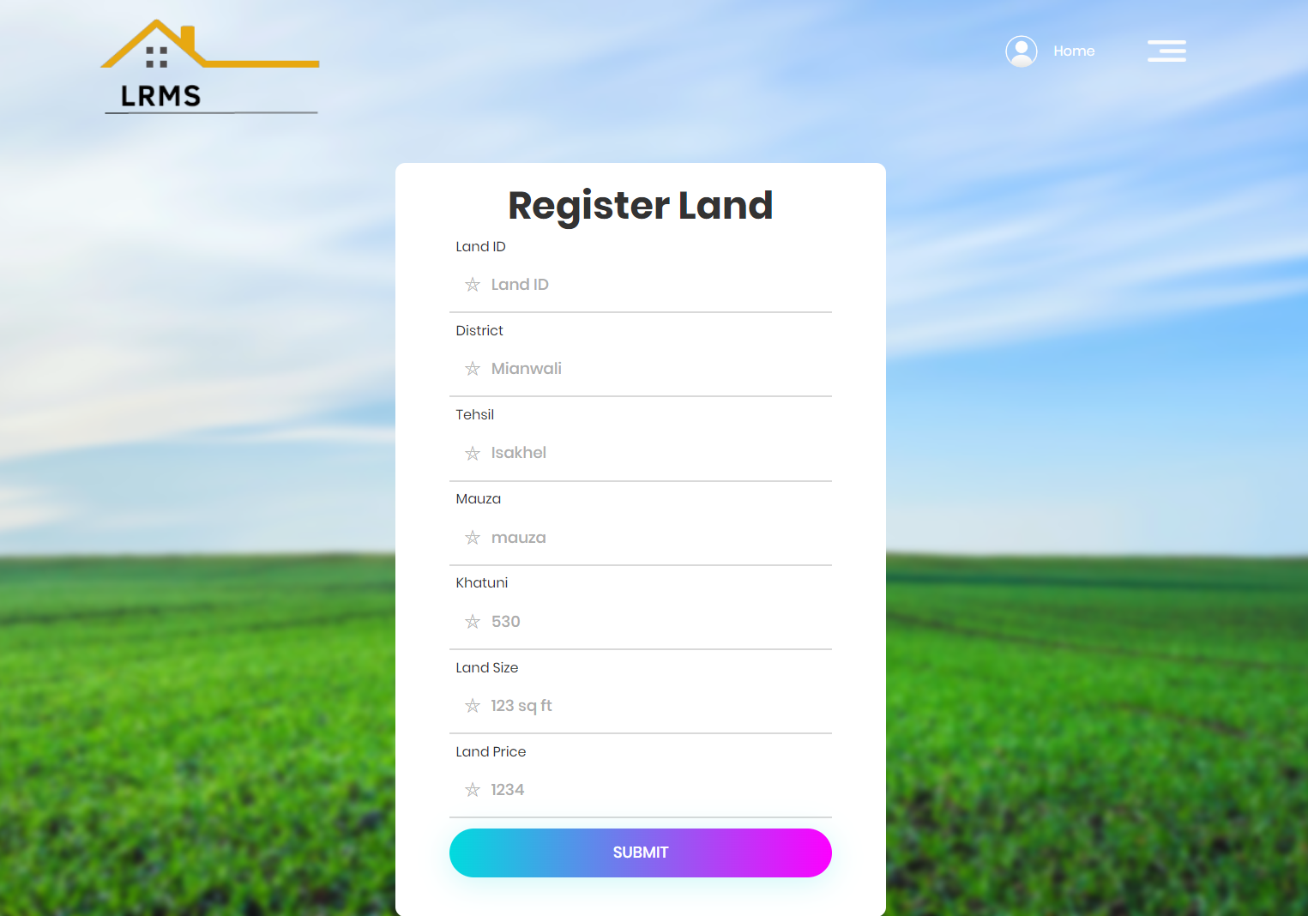

1. **Search Land History Page**

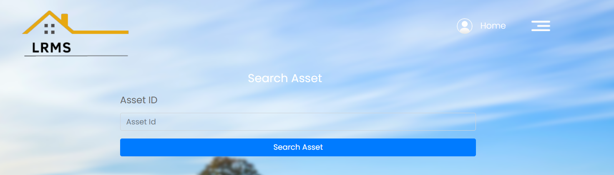

**After Search Asset**

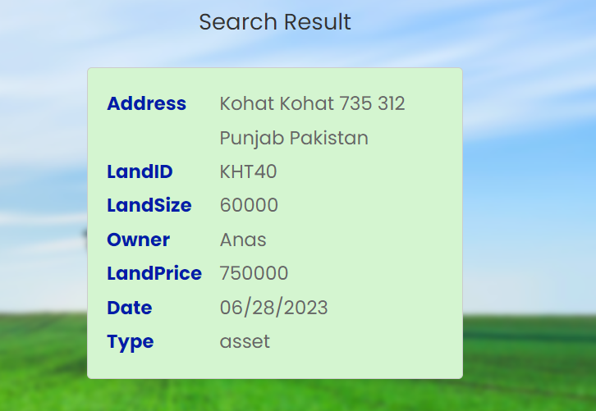

1. **Patwari Dashboard:**

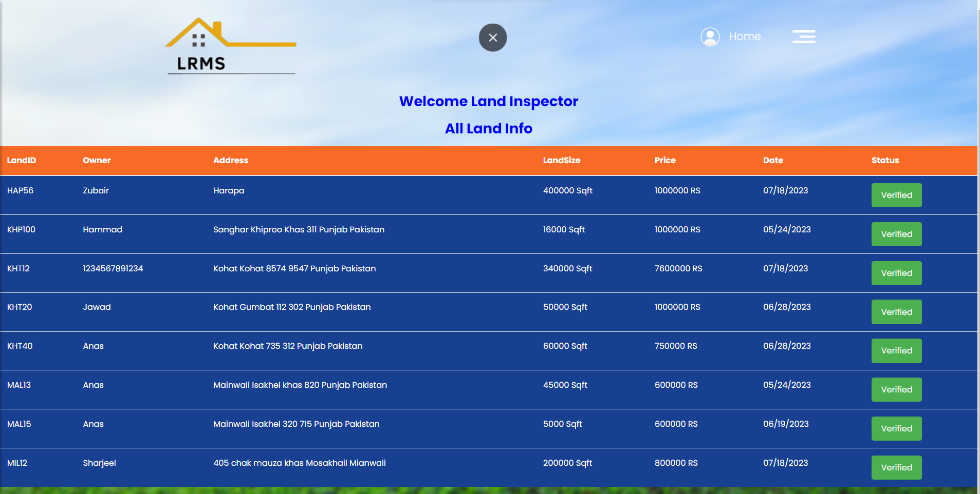

**Received Lands Requests:**

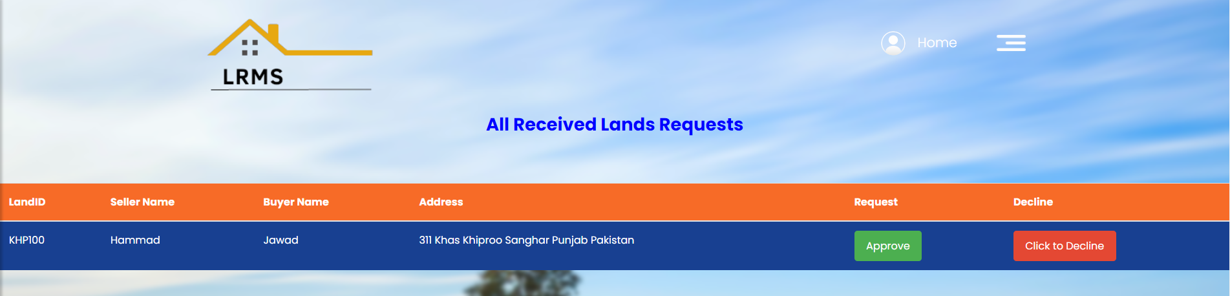

**Mobile Application**

1. **Home Page**  **2. Login Page**

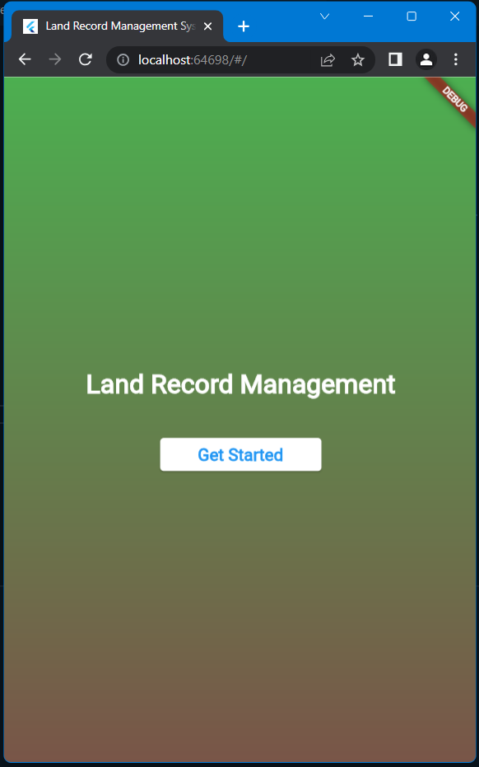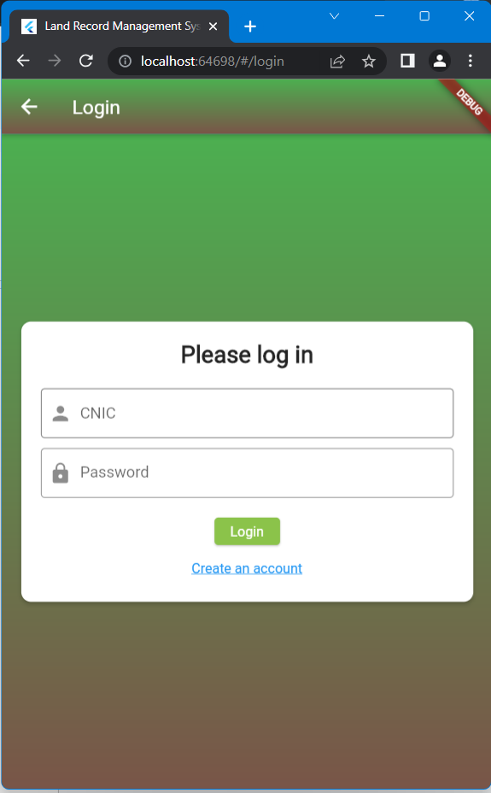

**3. Registration Page**  **4. Dashboard**

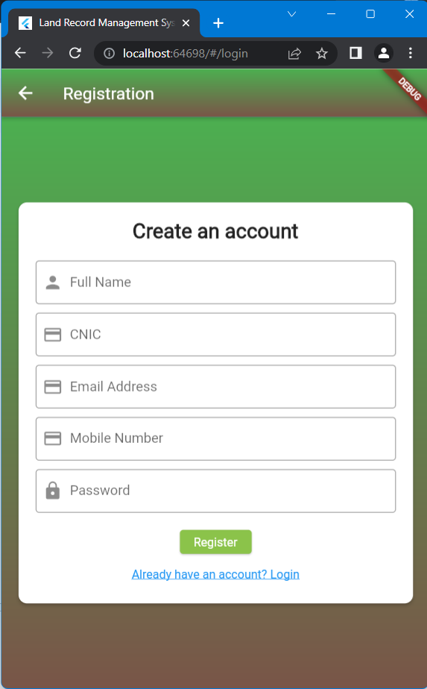 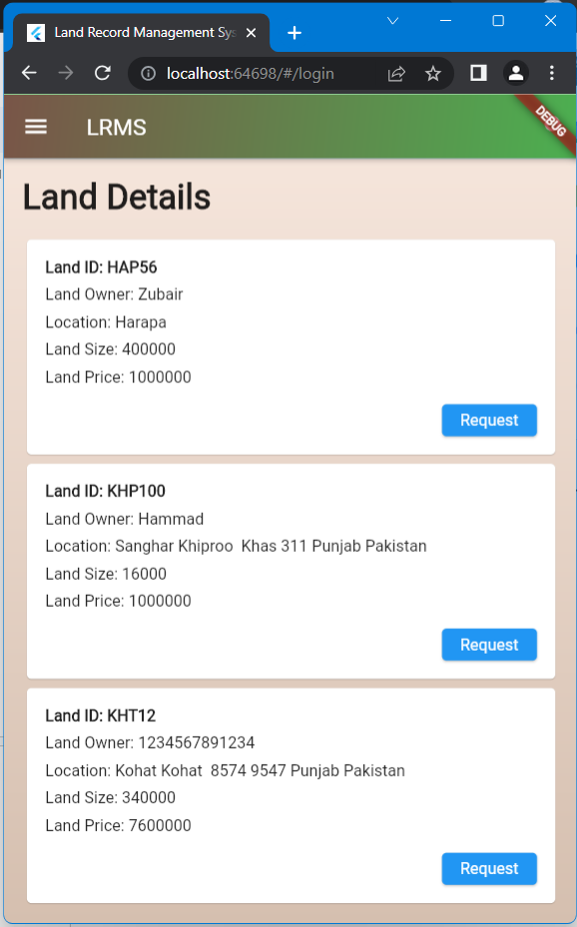

**5. Side Bar**  **6. All Requested Lands**

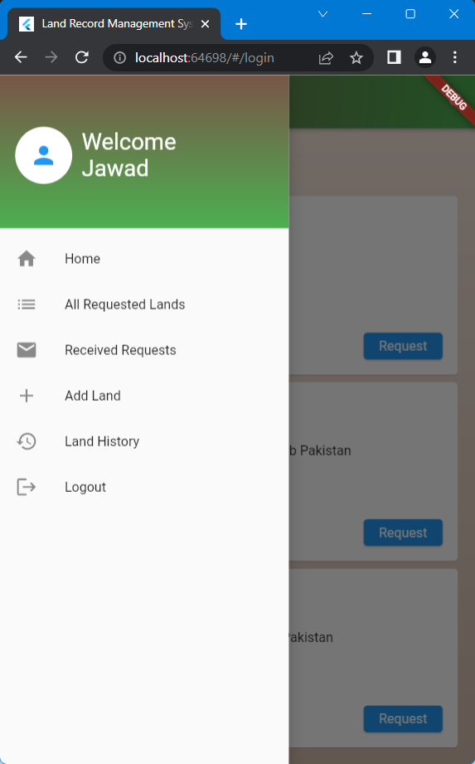 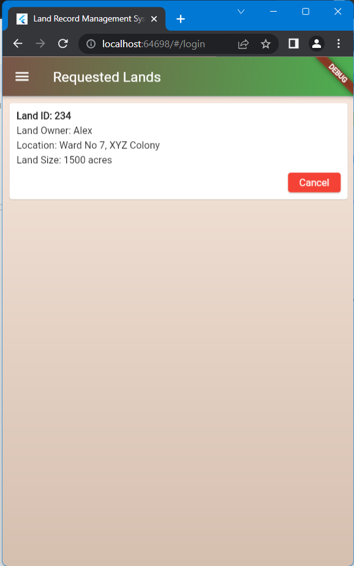

**7. Received Requests Page**  **8. Add Landform**

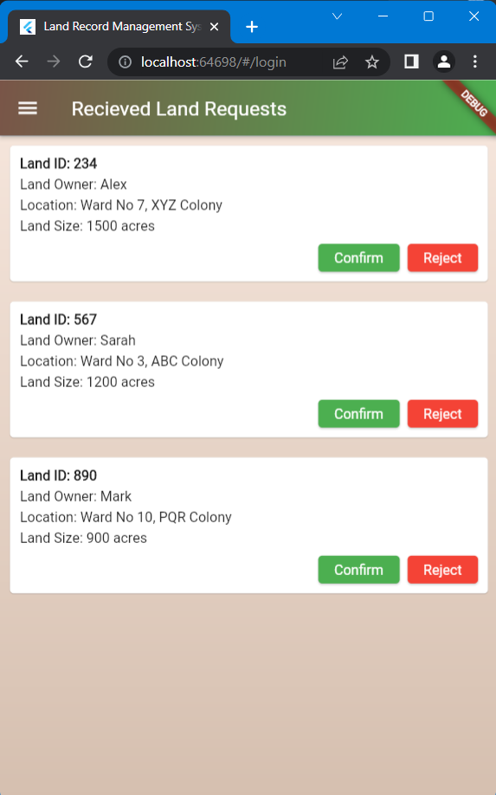 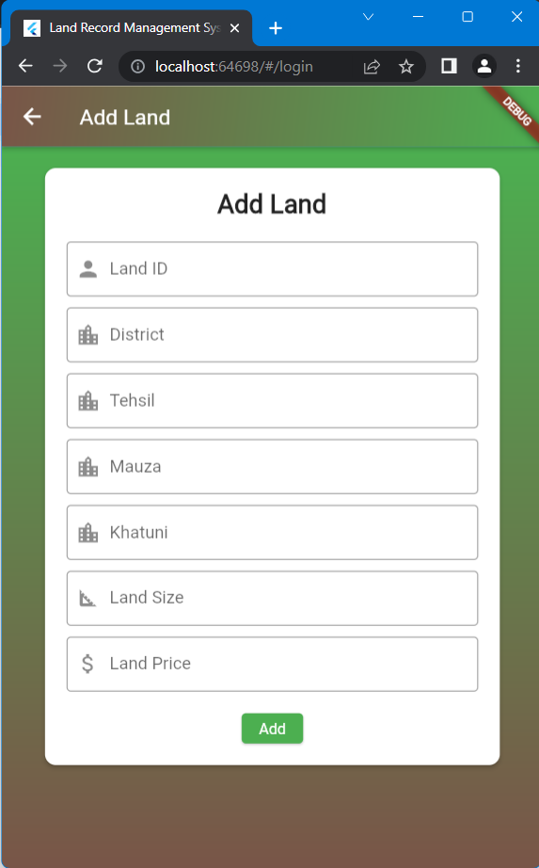

**9. Search Land History Page**

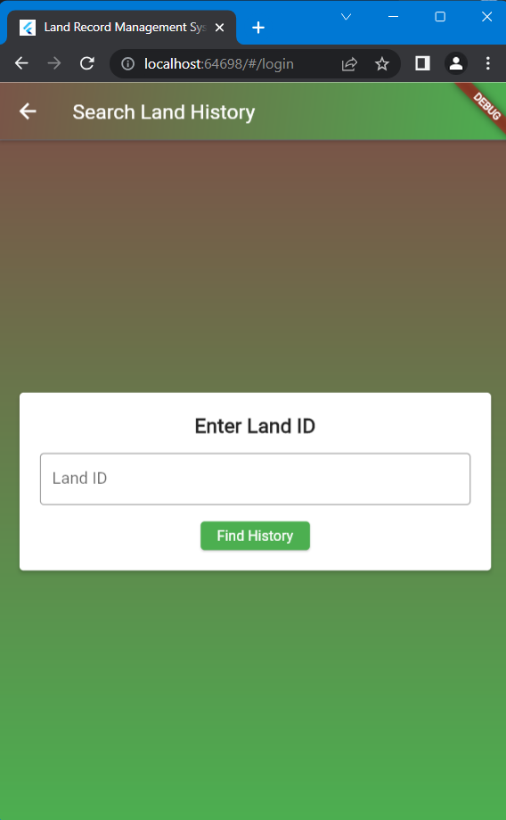

# 

# Chapter 8

## Conclusion

In conclusion, the system has addressed prominent issues with land record transactions, like data integrity, transparency, and security, by utilizing blockchain technology. The management of land records has been shown to be more dependable, efficient, and trustworthy since the deployment of the LRMS. The LRMS has shown to be a useful instrument for guaranteeing the correctness and immutability of land records through manual testing and review. The transparency that blockchain technology provides has increased stakeholder trust and stopped fraud and disagreements. Different components of land deals have been automated using smart contracts, expediting the procedure, and lowering dependency on intermediaries. Because all transactions are safely kept in an immutable blockchain ledger, the outcomes of the LRMS implementation point to better data integrity. As a result, it is impossible to tamper with land records, offering a trustworthy source of information on ownership and transaction history. Additionally, the technology has shown itself to be more effective, cutting down on manual paperwork and expediting the land transaction procedure.

The LRMS has made great progress, yet there is still room for growth and development. For the system to be successful overall, it is essential to guarantee the scalability of the blockchain network, user adoption and training, as well as ongoing support and maintenance. By overcoming these obstacles, the LRMS will be more widely used, and land record management will advance even further.

# Chapter 9

## Future Work

In addition to the milestones achieved, the use of blockchain technology in the Land Record Management System (LRMS) holds promise for future advancements and enhancements. The subsequent domains can be investigated to facilitate additional progress and refinement of the system:

**Enhanced Reporting and Analytics**

A potential area of future development applies to the enhancement of the reporting and analytics functionalities of the LRMS. This includes the creation of extensive reporting capabilities for generating statistical reports, conducting trend analysis, and producing visual representations related to land records, transactions, and system performance. The utilization of data analytics techniques can facilitate the detection of patterns, anomalies, and predictive analysis, thereby yielding valuable insights.

**Integration with External Systems**

The investigation of potential avenues for integrating the Land Record Management System (LRMS) with external systems and services can enhance its functionality and facilitate smooth data exchange. The integration of geolocation services into the LRMS enables the inclusion of geospatial data and mapping functionalities. The incorporation of payment gateways can enhance the security of online payment processing for land transactions, thereby optimizing the overall user experience.

**Continuous Performance Optimization**

Continuous performance optimization is a critical practice that involves the ongoing monitoring and enhancement of the performance of the LRMS. This is essential to achieve efficient response times, scalability, and optimal resource utilization. Conducting periodic load testing across different scenarios can facilitate the identification of performance bottlenecks and enable system optimization to effectively manage heightened user load and transaction volumes. Including caching mechanisms and utilizing performance tuning techniques can enhance system responsiveness and scalability.

**Blockchain Network Scalability**

To effectively handle a greater volume of land records and transactions without compromising the advantages offered by blockchain technology, it is essential to investigate approaches that can improve the scalability of the underlying blockchain network. The investigation of sharding, side chains, or off-chain solutions may be necessary in order to facilitate effective scalability of the LRMS.

**Security Enhancements**

Prioritization of reinforcing the security measures of the LRMS is imperative. Regularly conducting security audits, penetration testing, and adhering to industry standards and regulations can aid in the identification and mitigation of potential threats and vulnerabilities. The enhancement of data security and privacy can be achieved through the implementation of multi-factor authentication, encryption techniques, and secure communication protocols.

**Integration with AI (Artificial Intelligence) and Machine Learning**

Integrating artificial intelligence (AI) and machine learning (ML) techniques can automate processes and enhance decision-making within the LRMS. This may entail developing machine learning models to identify anomalies or instances of fraud within land transactions and records. Furthermore, the utilization of AI algorithms enables the automation of data extraction and validation from diverse sources, thereby enhancing overall operational efficiency.

## References

1. Aquib, M., Dhomeja, L. D., Dahri, K., & Malkani, Y. A. (2020, January). Blockchain-based land record management in pakistan. In 2020 3rd International Conference on Computing, Mathematics and Engineering Technologies (iCoMET) (pp. 1-5). IEEE.
2. Benbunan-Fich, R., & Castellanos, A. (2018). Digitization of land records: From paper to blockchain.
3. Alam, K. M., Rahman, J. A., Tasnim, A., & Akther, A. (2022). A blockchain-based land title management system for Bangladesh. Journal of King Saud University-Computer and Information Sciences, 34(6), 3096-3110.
4. Mukne, H., Pai, P., Raut, S., & Ambawade, D. (2019, July). Land record management using hyperledger fabric and ipfs. In 2019 10th International Conference on Computing, Communication and Networking Technologies (ICCCNT) (pp. 1-8). IEEE.
5. Wadud, M. A. H., Ahmed, T., Hossen, A., Hasan, M. M., Islam, M. A., & Rahman, M. H. (2023). A Blockchain-Based Secured Land Record System Using Hyperledger Fabric. In The Fourth Industrial Revolution and Beyond: Select Proceedings of IC4IR+ (pp. 171-184). Singapore: Springer Nature Singapore.
6. Zhong, B., Wu, H., Ding, L., Luo, H., Luo, Y., & Pan, X. (2020). Hyperledger fabric-based consortium blockchain for construction quality information management. Frontiers of engineering management, 7(4), 512-527.
7. Dcunha, L., Dsouza, L., Ramanan, G., & Chaudhari, S. (2023, March). A Blockchain-Based Approach to Streamlining Land Registration using Hyperledger Fabric. In 2023 International Conference on Emerging Smart Computing and Informatics (ESCI) (pp. 1-6). IEEE.
8. Cachin, C. (2016, July). Architecture of the hyperledger blockchain fabric. In Workshop on distributed cryptocurrencies and consensus ledgers (Vol. 310, No. 4, pp. 1-4).
9. Foschini, L., Gavagna, A., Martuscelli, G., & Montanari, R. (2020, June). Hyperledger fabric blockchain: Chaincode performance analysis. In ICC 2020-2020 IEEE International Conference on Communications (ICC) (pp. 1-6). IEEE.
10. Li, D., Wong, W. E., & Guo, J. (2020, January). A survey on blockchain for enterprise using hyperledger fabric and composer. In 2019 6th International Conference on Dependable Systems and Their Applications (DSA) (pp. 71-80). IEEE.
11. Schach, S. R. (1990). Software engineering. Aksen associates.
12. Morris, S. J., & Gotel, O. C. Z. (2006, June). Flow diagrams: rise and fall of the first software engineering notation. In the International Conference on Theory and Application of Diagrams (pp. 130-144). Berlin, Heidelberg: Springer Berlin Heidelberg.
13. Reifer, D. J. (2000). Web development: estimating quick-to-market software. IEEE software, 17(6), 57-64.
14. Győrödi, C. A., Dumşe-Burescu, D. V., Zmaranda, D. R., Győrödi, R. Ş., Gabor, G. A., & Pecherle, G. D. (2020). Performance analysis of NoSQL and relational databases with CouchDB and MySQL for application’s data storage. Applied Sciences, 10(23), 8524.
15. Sukhwani, H., Wang, N., Trivedi, K. S., & Rindos, A. (2018, November). Performance modeling of hyperledger fabric (permissioned blockchain network). In 2018 IEEE 17th international symposium on network computing and applications (NCA) (pp. 1-8). IEEE.

**APPENDICES**

**Commands To Run Application**

* Install WSL on Latest Windows wsl --install
* Check Docker Desktop and Docker Compose Versions docker -v docker-compose -v
* Check Ubuntu and Docker States wsl -l -v
* Check Curl Version curl --version
* Install Node.js and NPM:
* curl o https://raw.githubusercontent.com/nvm... | bash
* nvm install node
* Install and Use NVM and Check Versions of Node and NPM nvm install 10.23.0 or use the latest one nvm use 10.23.0 node -v npm -v

**Install Front End Application Dependencies**

* npm install express express-layout path cookie-parser express-session
* npm install ipfs-http-client@42.0.0

**Start Hyperledger Fabric Land Network**

* cd asset/fabric-samples/test-network
* ./network.sh down
* ./network.sh up createChannel -c mychannel -ca -s couchdb
* ./network.sh deployCC -ccn basic -ccp ../asset-transfer-basic/chaincode-javascript/ -ccl javascript /

**Launch the Asset Transfer Front-End Application**

* cd asset/fabric-samples/asset-transfer-basic/application-javascript
* nvm use 10.23.0
* npm start
* localhost:3001

**References**

Help has been taken from the following resources in preparing this document. I am thankful to the owners of the respective resources for making them available online for consultation.

About Plagiarism available online at:

<https://plagiarism.org/>

NUST (National University of Sciences and Technology) SEECS FYP Guidelines available online at:

<http://seecsnust.seecs.edu.pk/Internal/downloads/downloads/fyp/fyp-new/FYP_Guidelines_02_11_2017_v1.4.pdf>

Citation style guidelines available online at:

<https://ieeeauthorcenter.ieee.org/wp-content/uploads/IEEE-Reference-Guide.pdf>